**Gadget N Gadget**

**Issue1:** Source code is showing in the web page.

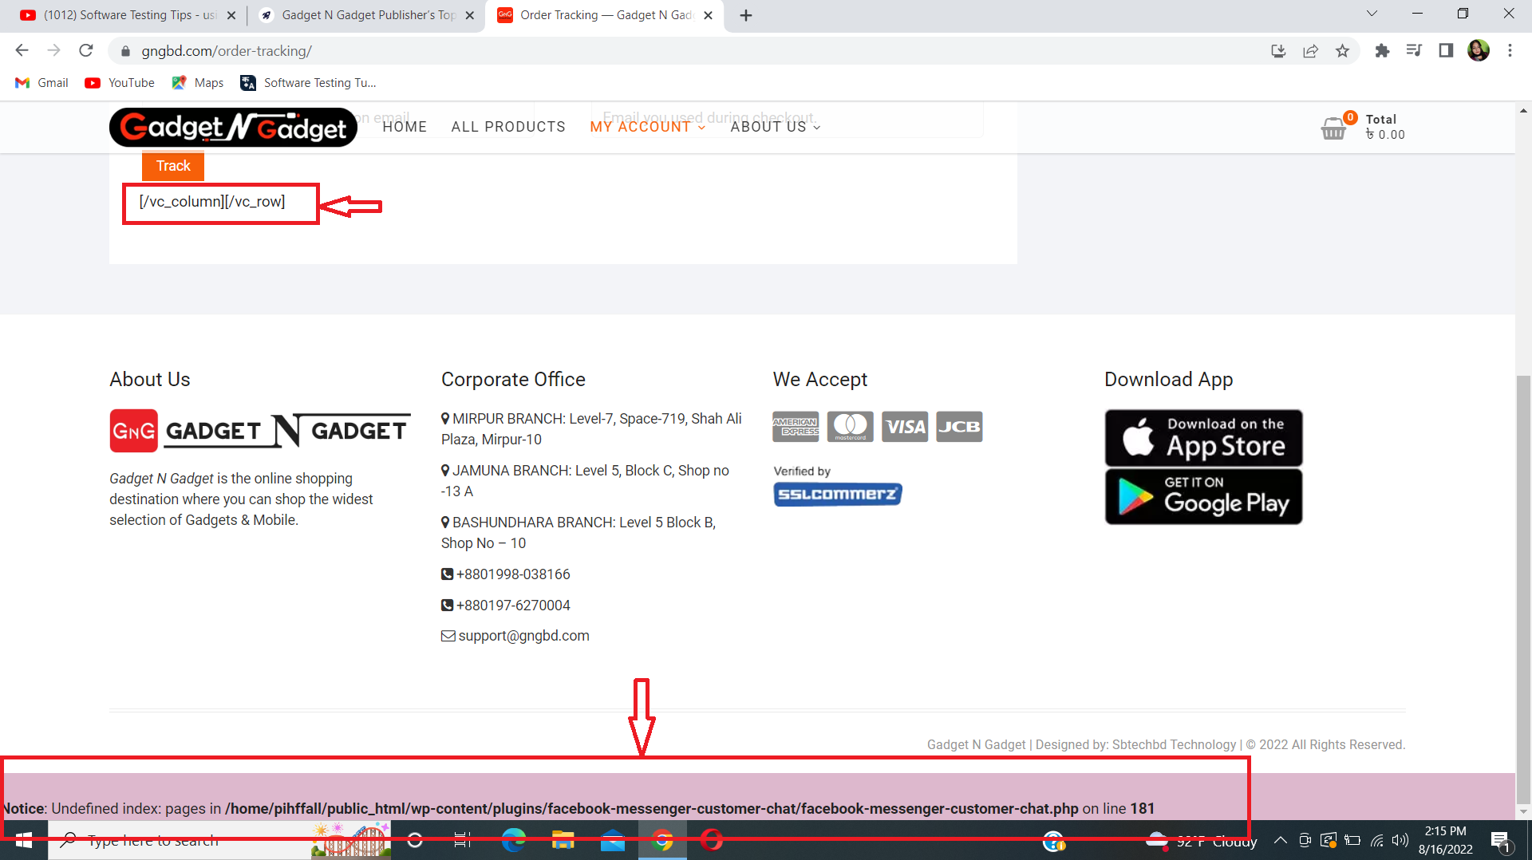

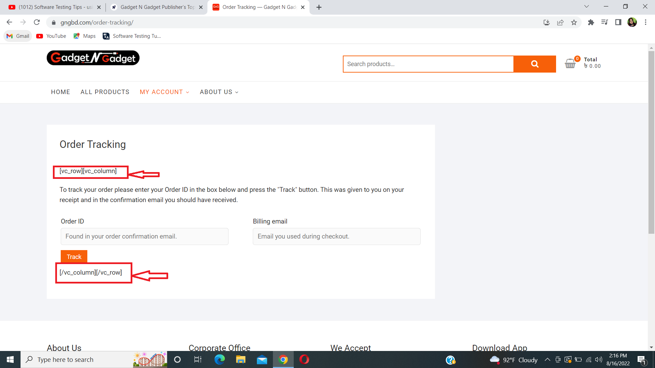

**Description:**

1. Go to URL (<https://gngbd.com/>)
2. Click on “MY ACCOUNT”
3. then click on “Order Tracking”
4. Website’s source code is showing the web page and also in footer source code error is showing.

**Observation,** Source code should not be shown and error should be fixed.

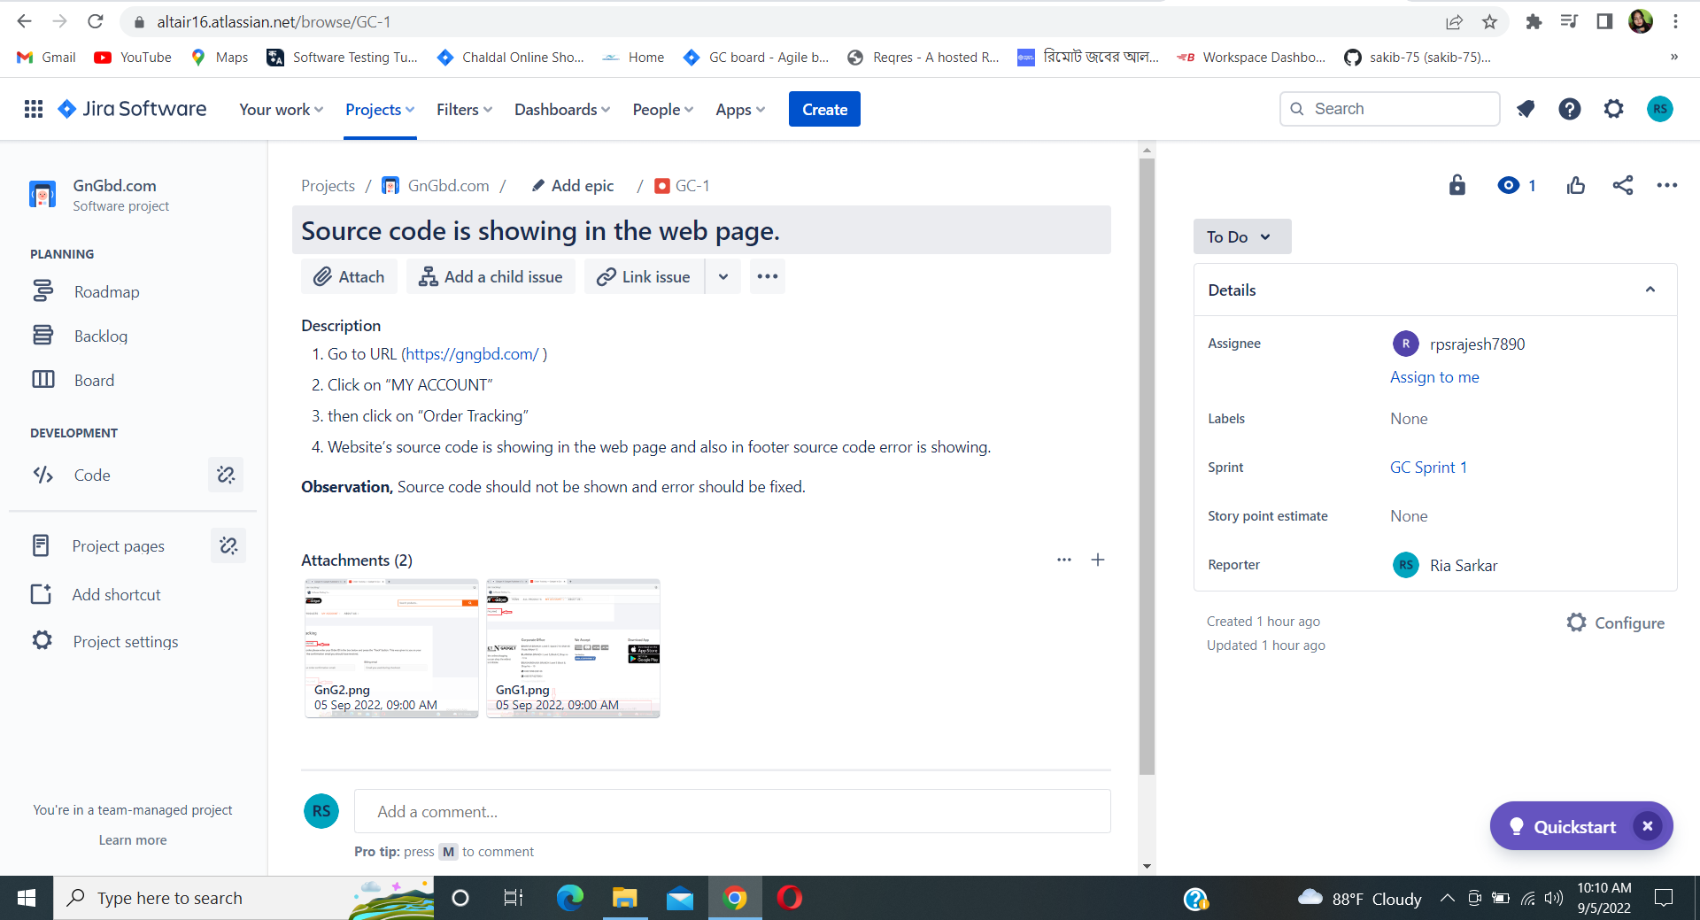

Description: The work was assigned to Rajesh Sarkar for solving the issue.

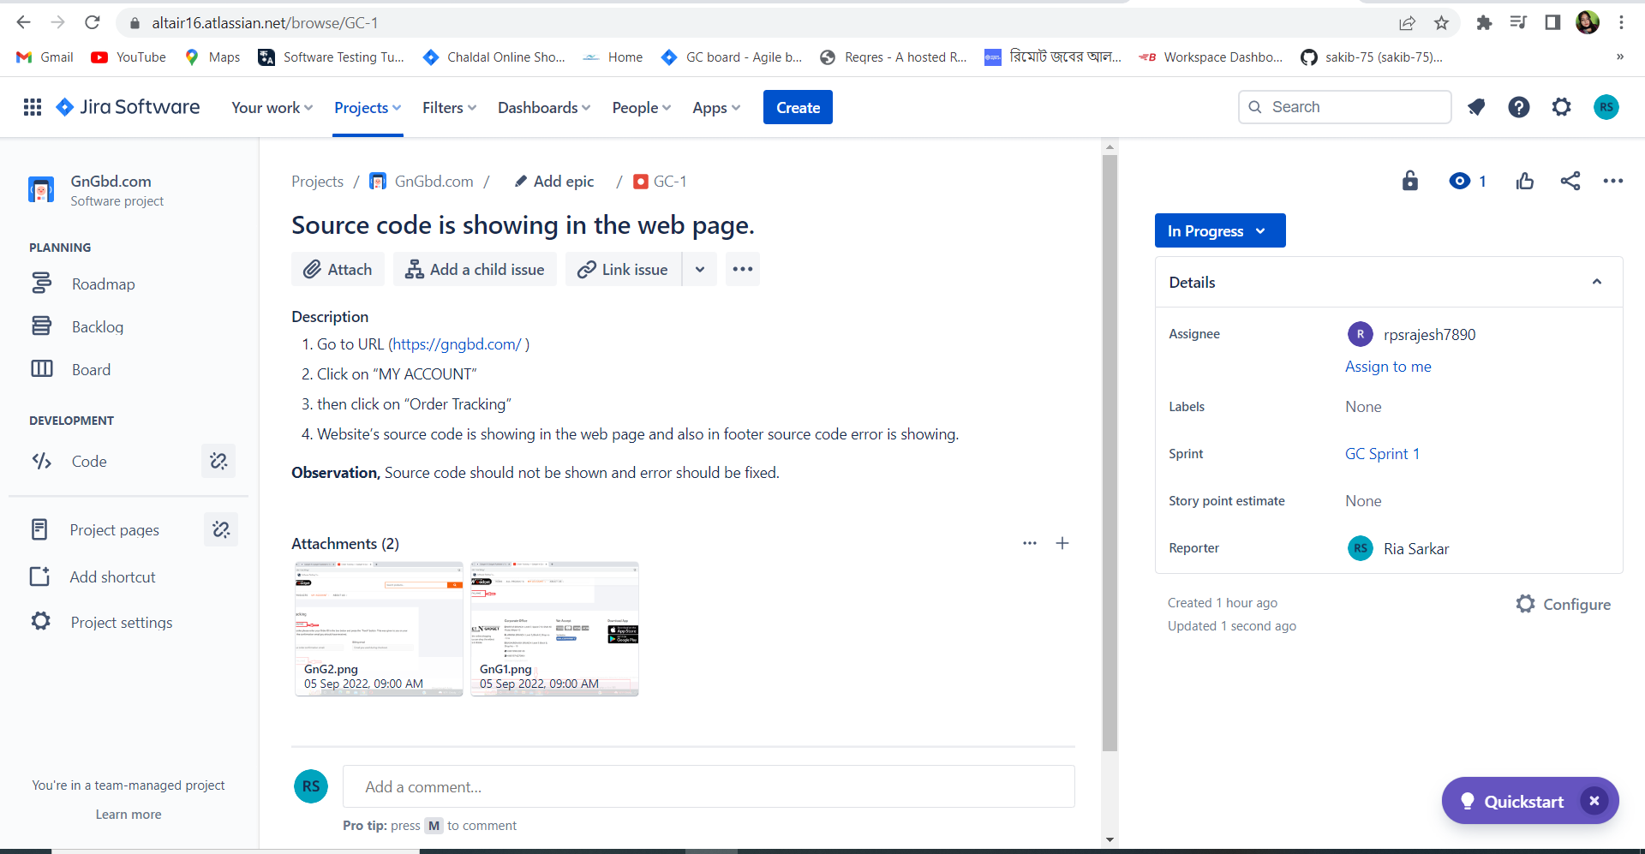

Description: The developer was working and it was in the progress stage.

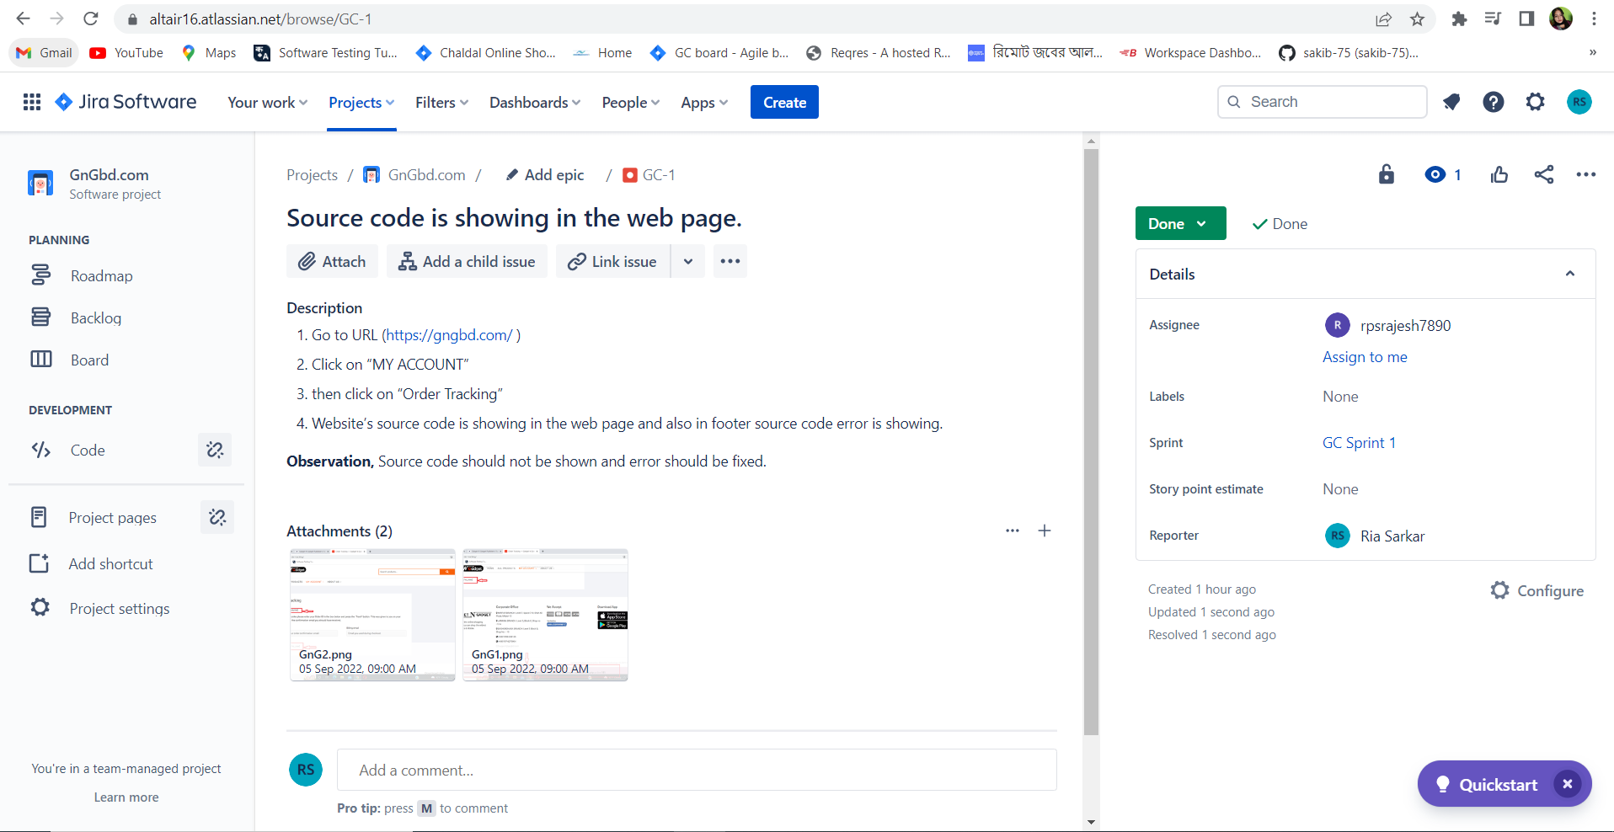

Description: Developer completed the work and the work is done.

**Issue2:**No information is not provided in the "About us" and "Contact us" section.

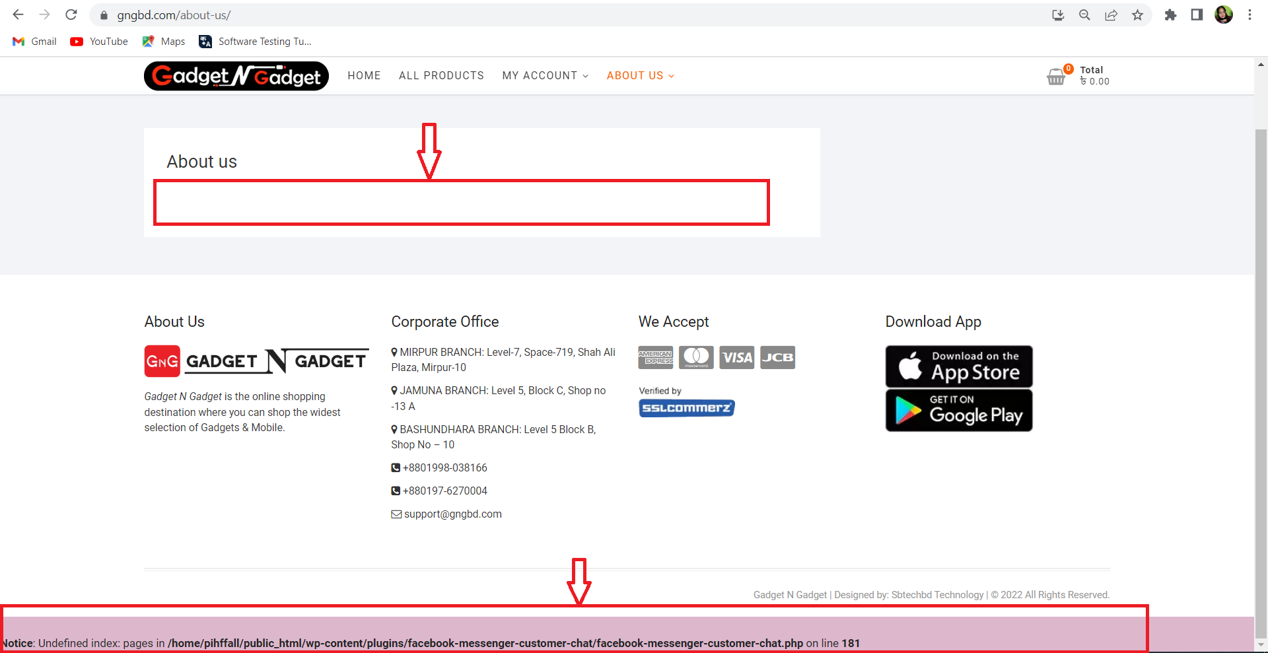

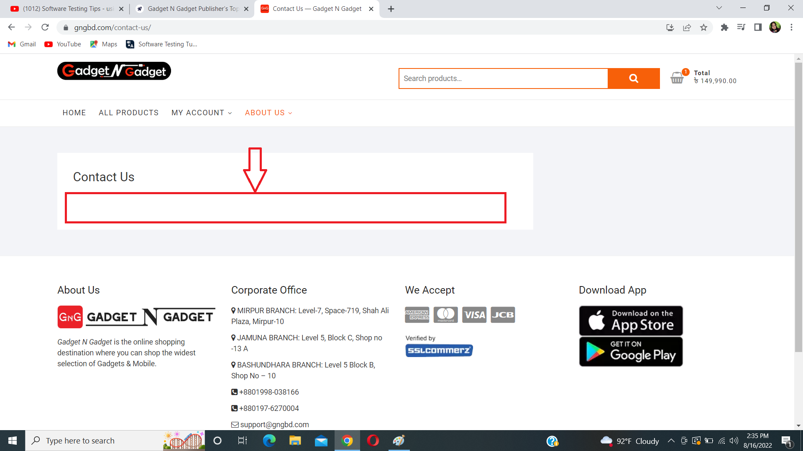

**Description,**

1. Go to URL (<https://gngbd.com/>)
2. Click on “About us”
3. There is no information provided also source code is shown in footer and error is shown in 181 line.
4. Click on “Contact Us”
5. There is also no information in the contact us field.

**Observation,** Every field should carry minimum information.

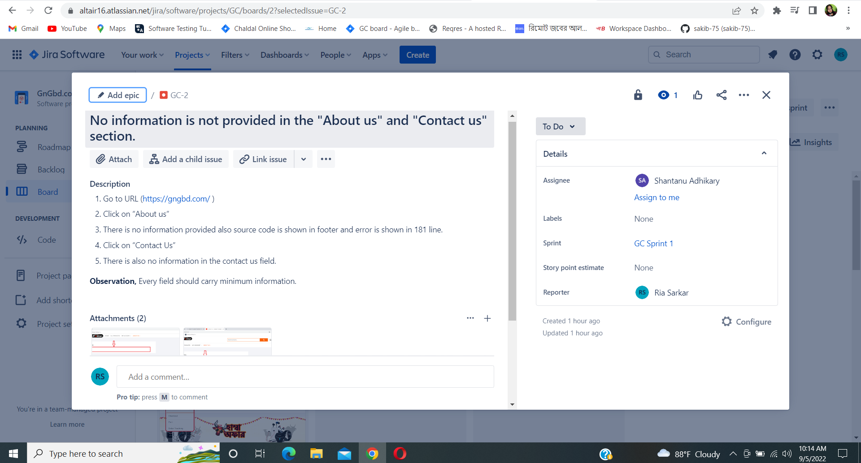

Description: The work was assigned to Shantanu Adhikary for solving the issue.

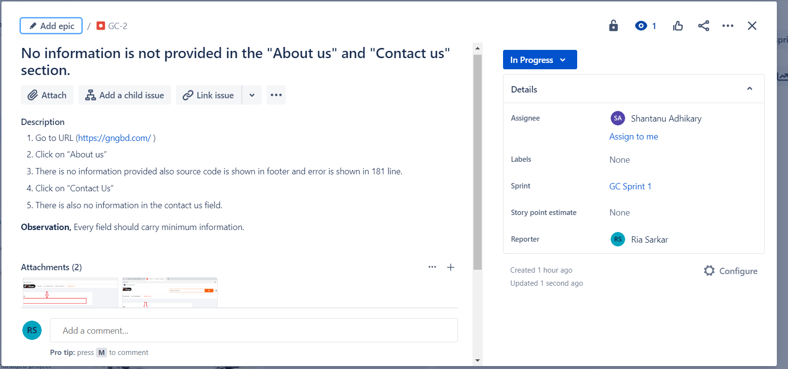

Description: The developer was working and it was in the progress stage.

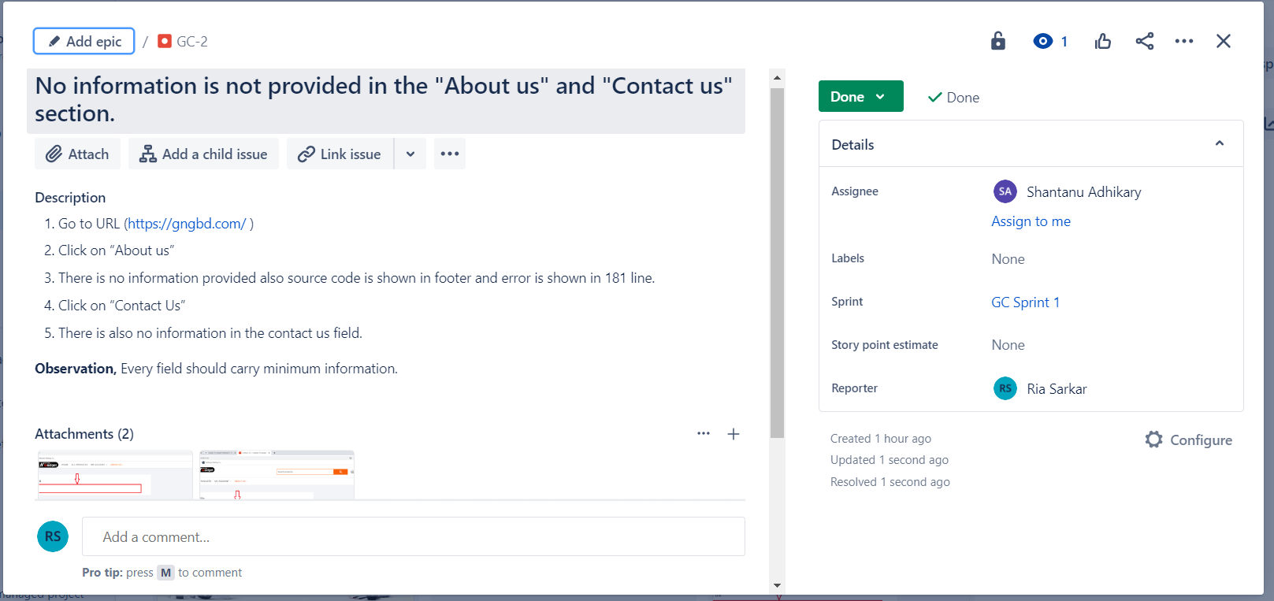

Description: Developer completed the work and the work is done.

**Issue3:** There is no Login/ Sign in option in MY ACCOUNT and also have an error in the checkbox.

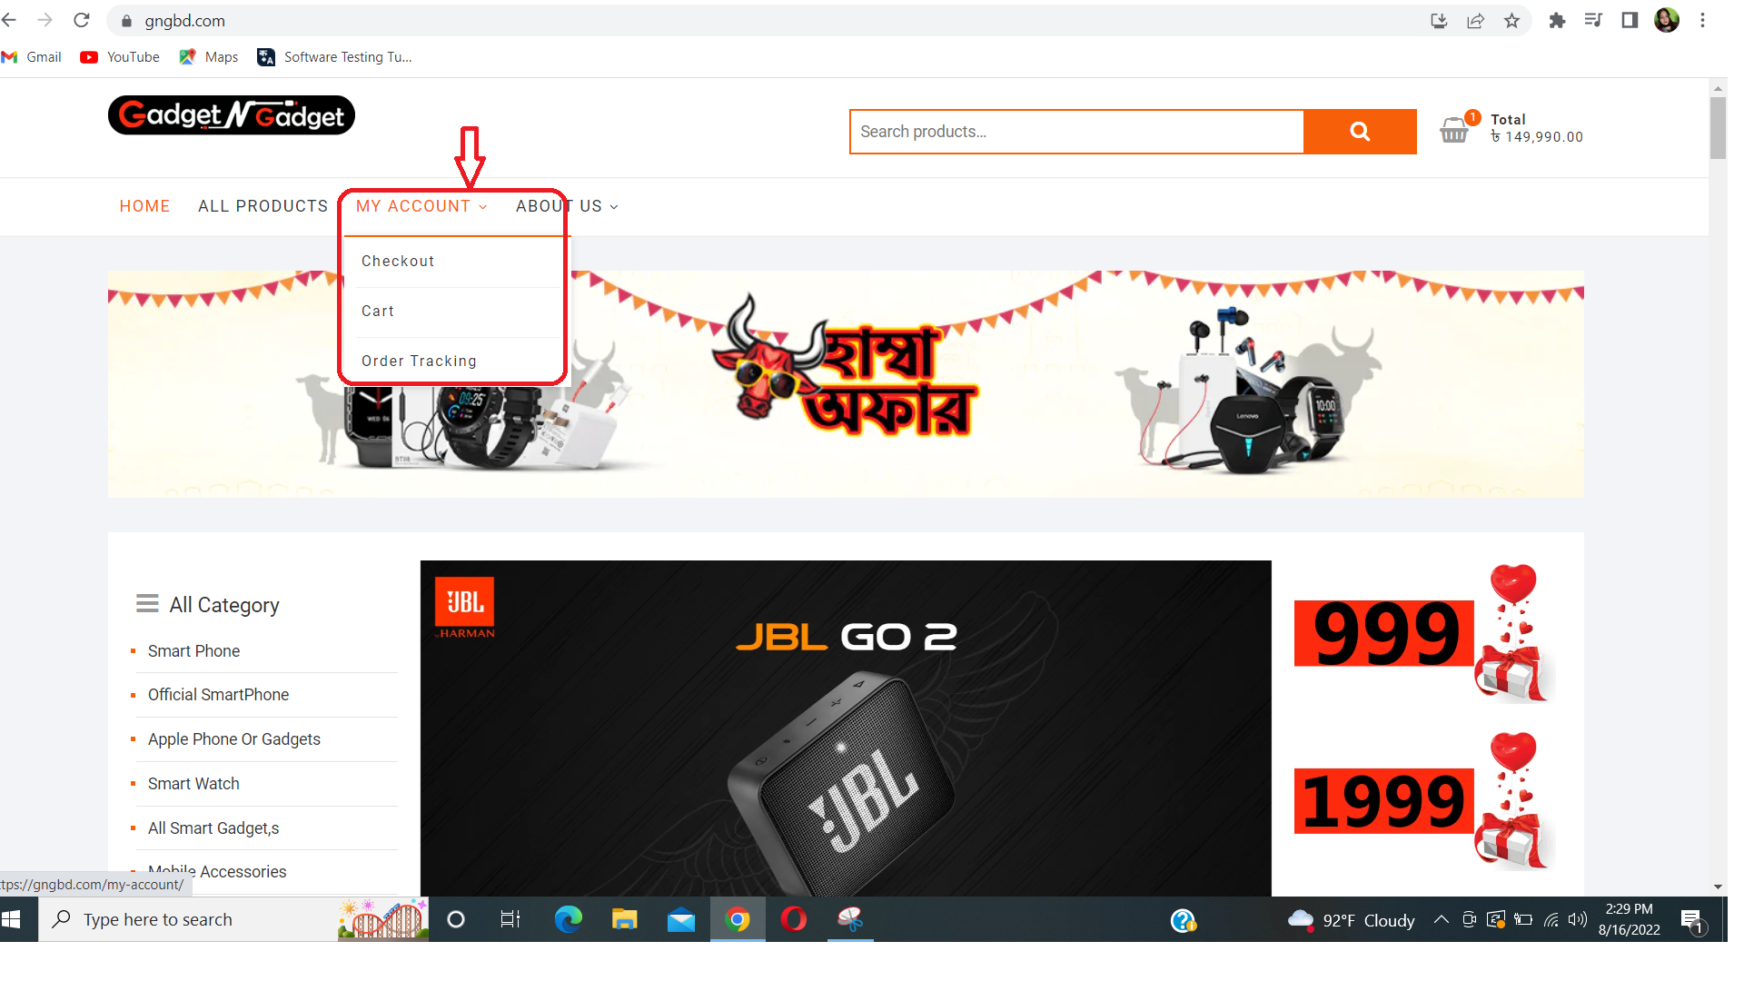

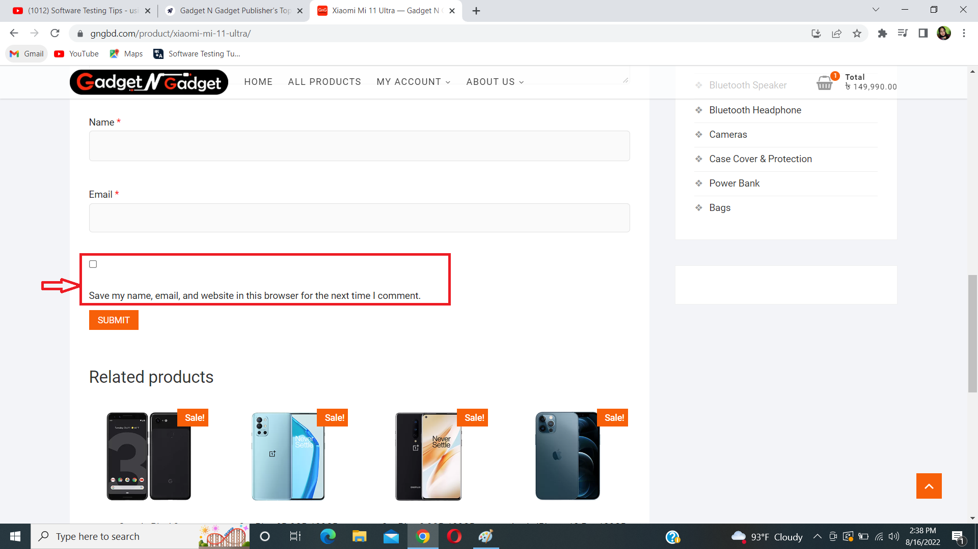

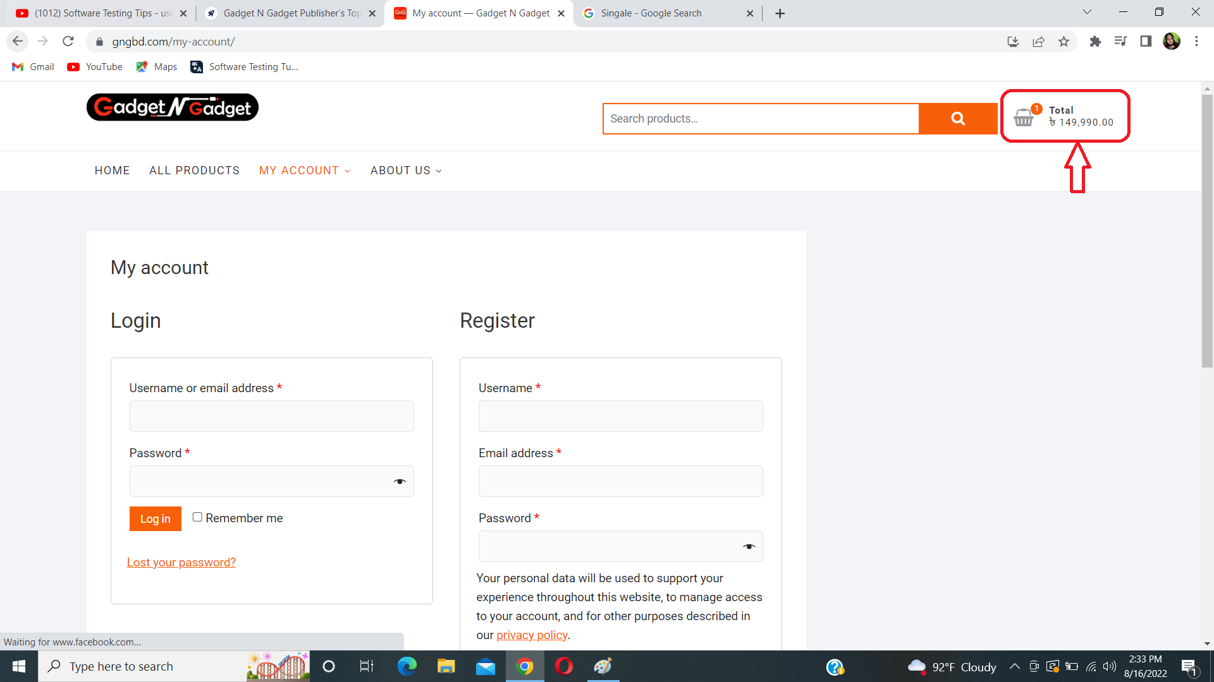

**Description:**

1. Go to URL(<https://gngbd.com/> )
2. Click on “MY ACCOUNT” from the menu bar.
3. There are only three options(Check out, Cart and Tracking order). No option for Login/Signup.
4. Users can add products in cart without any user account.
5. Also remember the checkbox is one line higher than the agreement statement .

**Observation,** My Account should have a login/signup option and the check box should be placed properly .

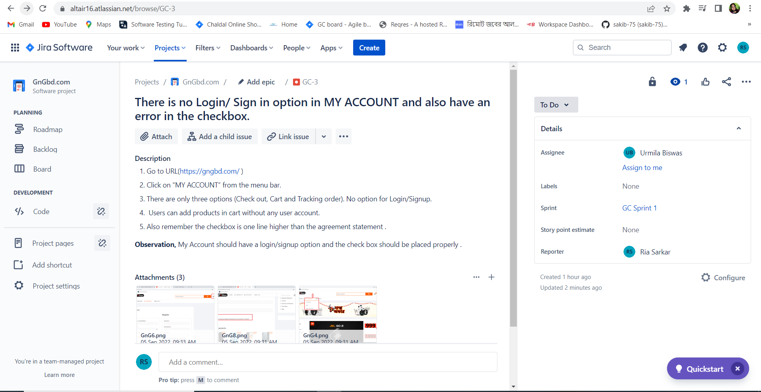

Description: The work was assigned to Urmila Biswas for solving the issue.

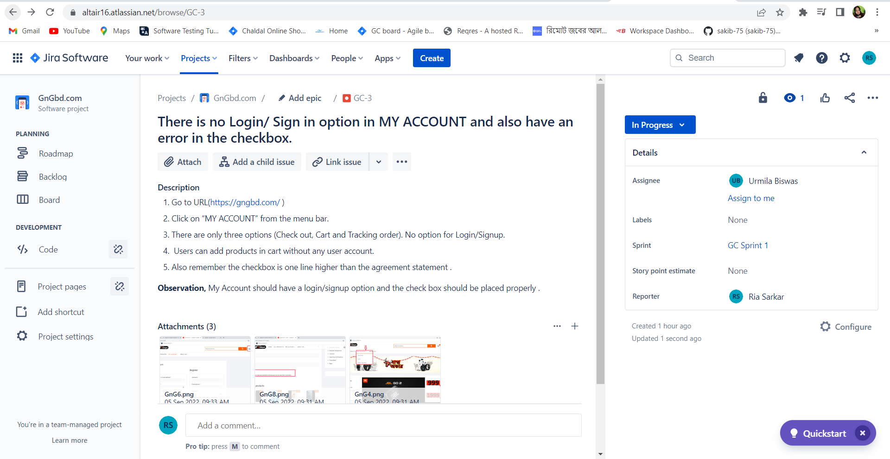

Description: The developer was working and it was in the progress stage.

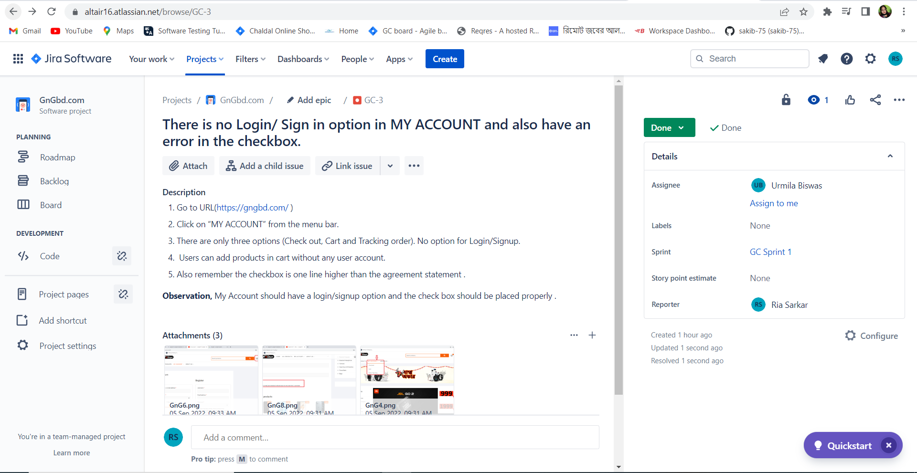

Description: Developer completed the work and the work is done.

**Issue4:** Spelling mistake in Home page.

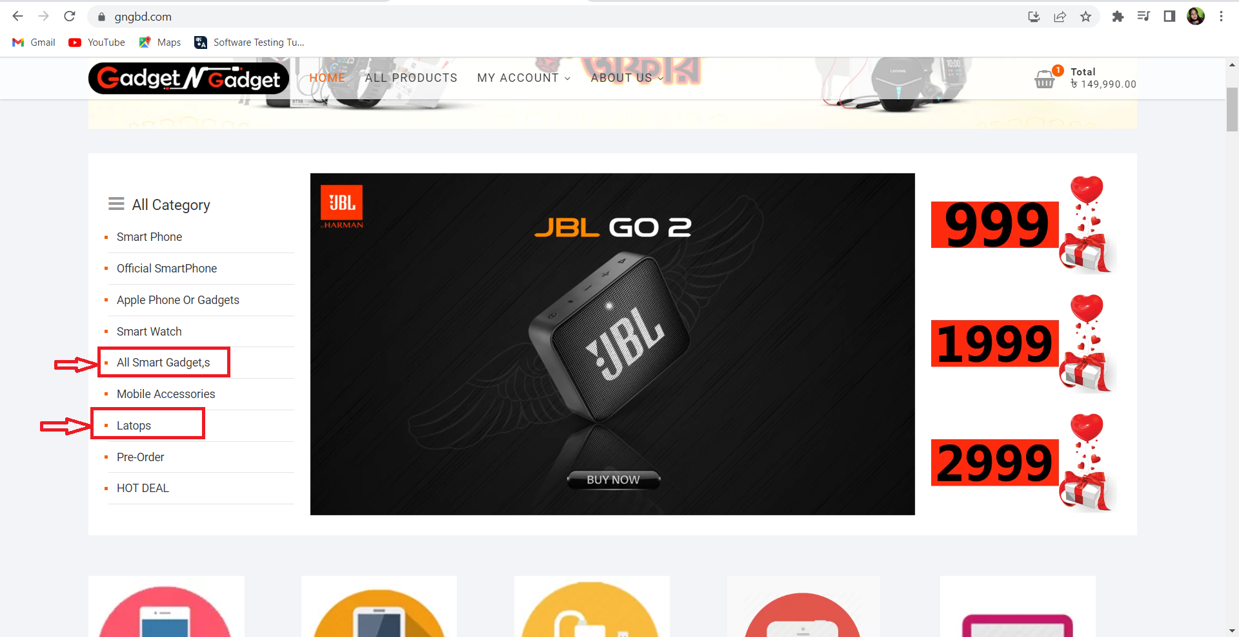

**Description:**

1. Go to URL(<https://gngbd.com/>)
2. In the upper left side of the home there is an option named “ All Category”.
3. In “All Category” section two option named “Latops” and “All Smart Gadget,s “ is incorrect.

**Observation,** In All Categories, the option name has spelling mistakes and the name should be “Laptop” and “All Smart Gadgets”.

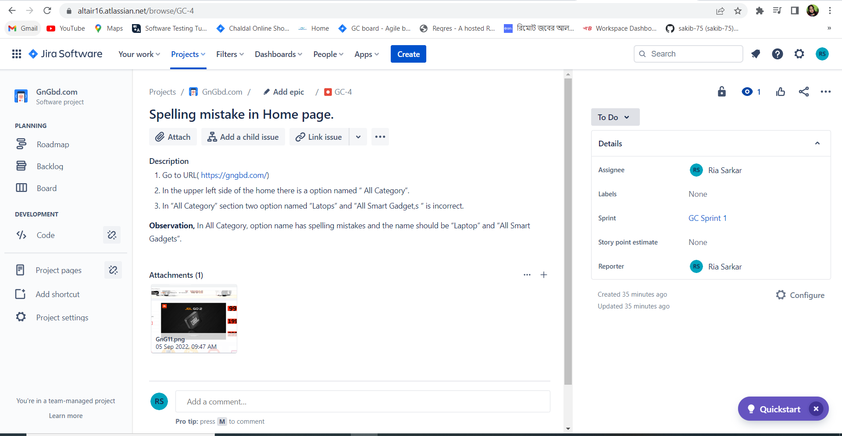

Description: Developer completed the work and the work is done.

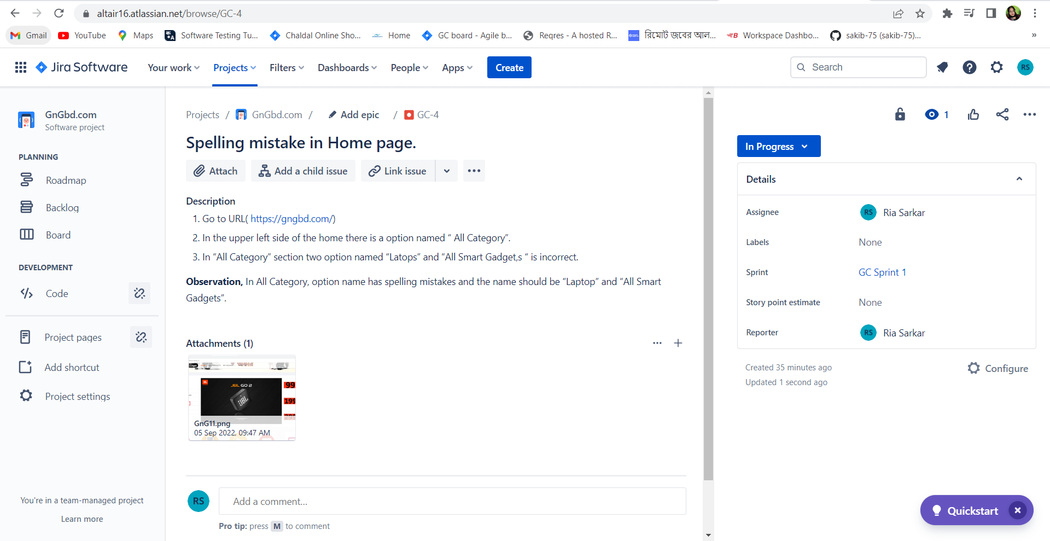

Description: The work was assigned to Ria Sarkar for solving the issue.

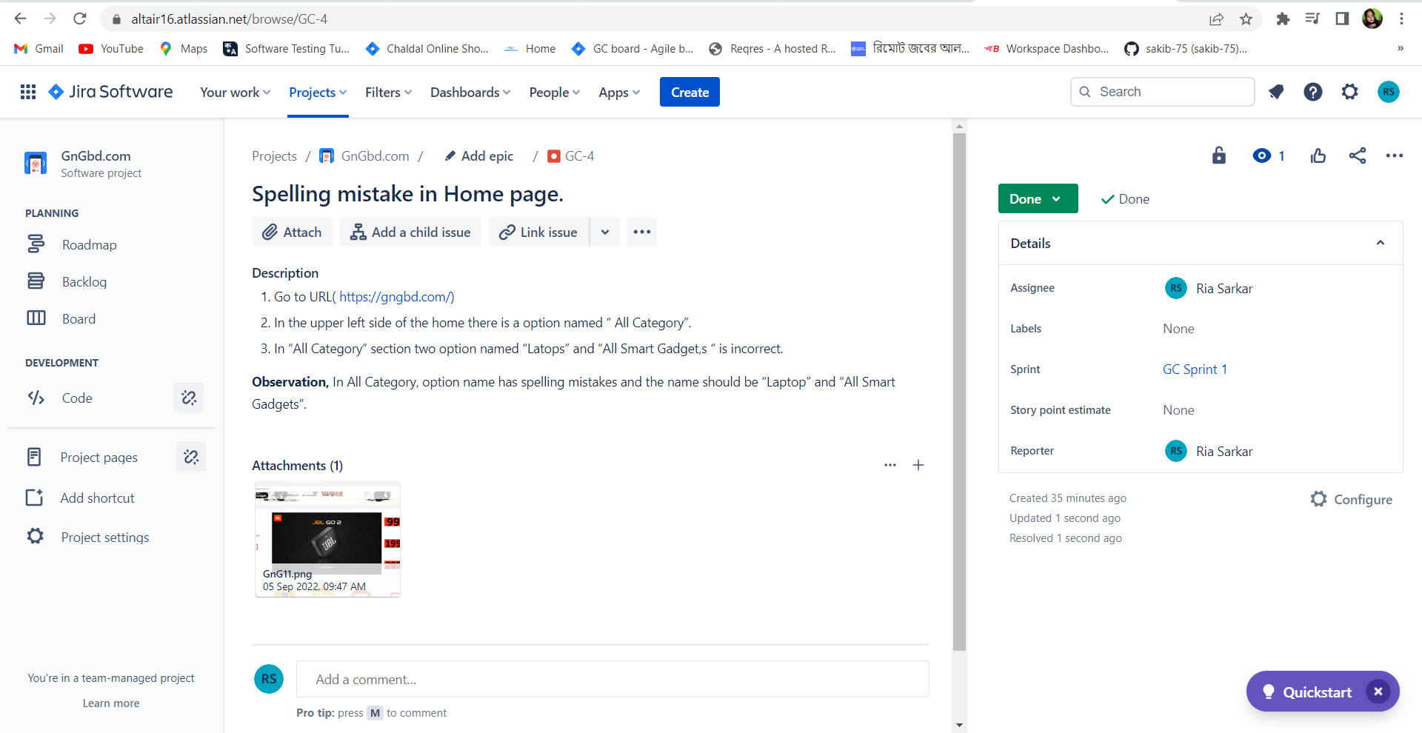

Description: Developer completed the work and the work is done.

**Issue5:**Product is not completely rearranged category wise.

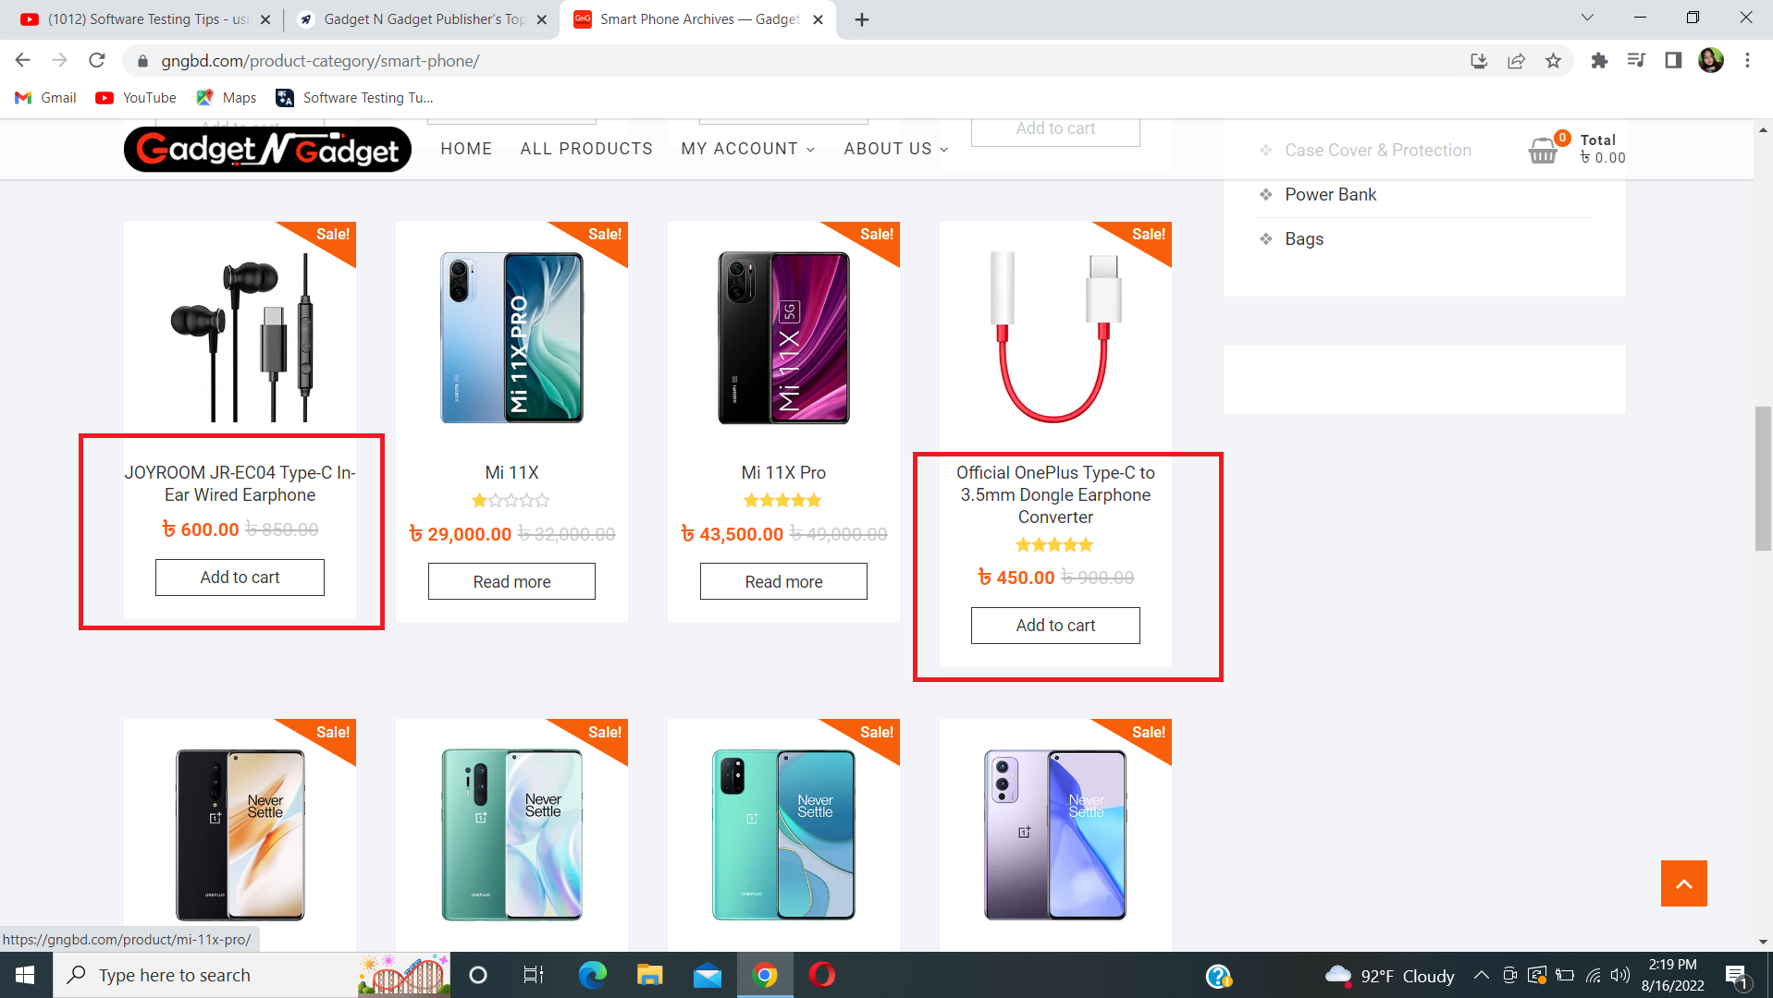

**Description:**

1. Go to URL(<https://gngbd.com/> )
2. Click on “ Smart Phone” from the All Category menu.
3. Besides cell phones there are some products like usb cable, earphones and other stuff which are not smartphones.

**Observation,** Product should be rearranged properly in its category.

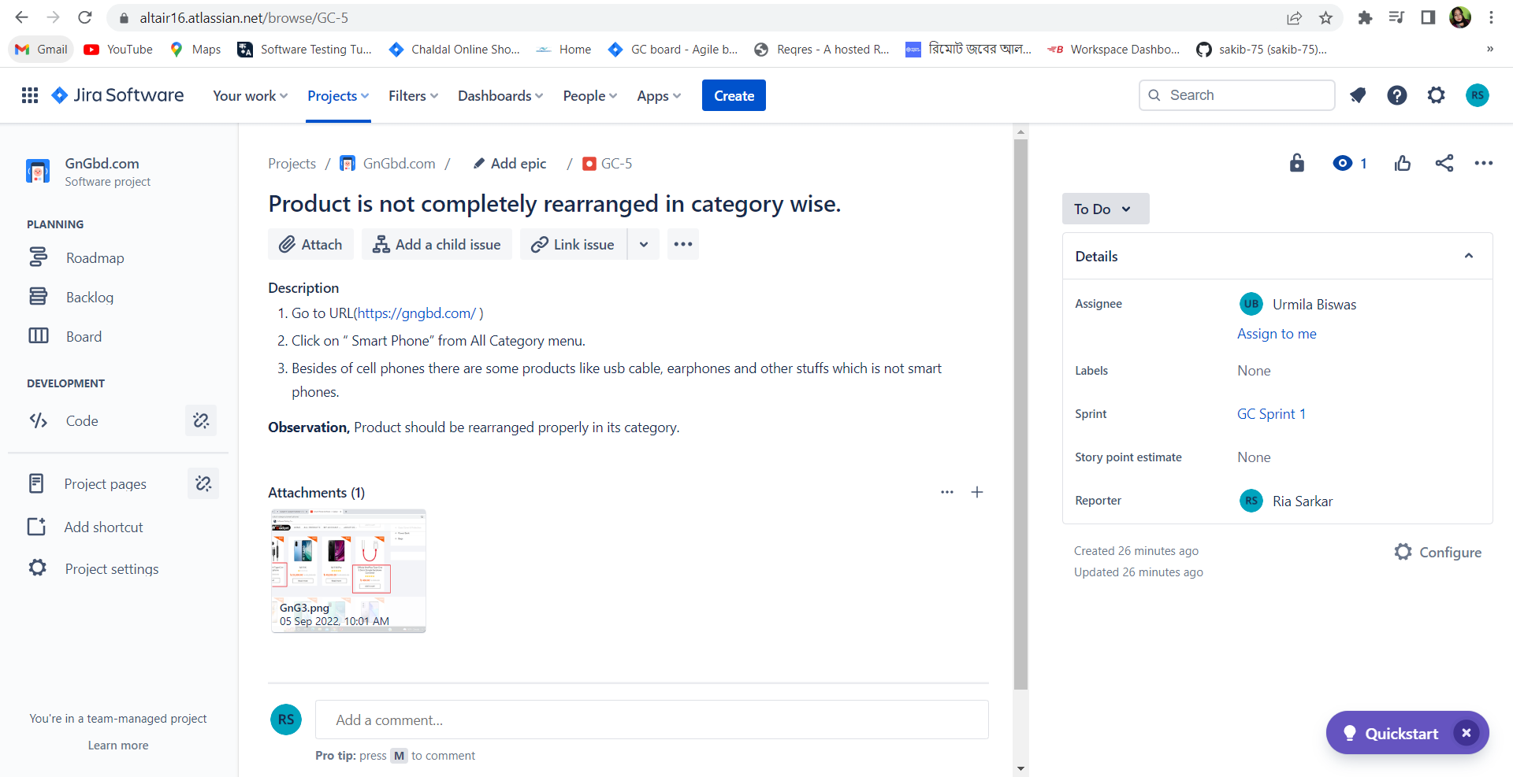

Description: The work was assigned to Urmila Biswas for solving the issue.

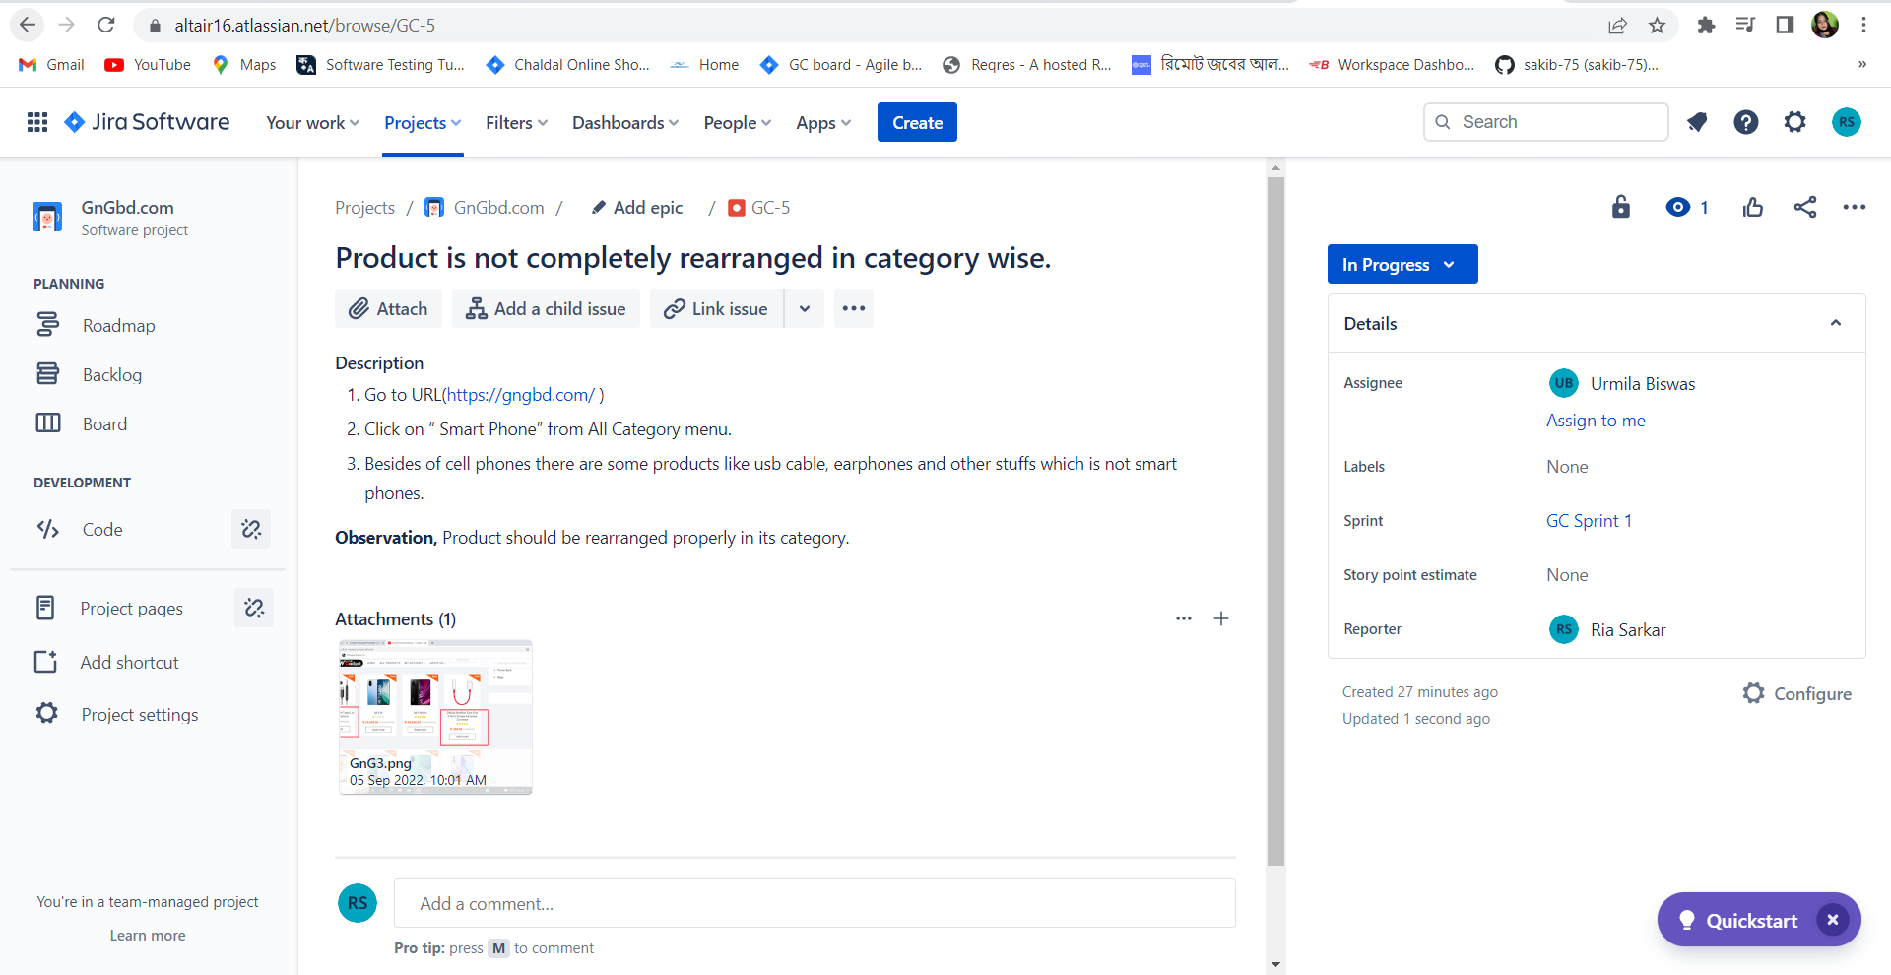

Description: The developer was working and it was in the progress stage.

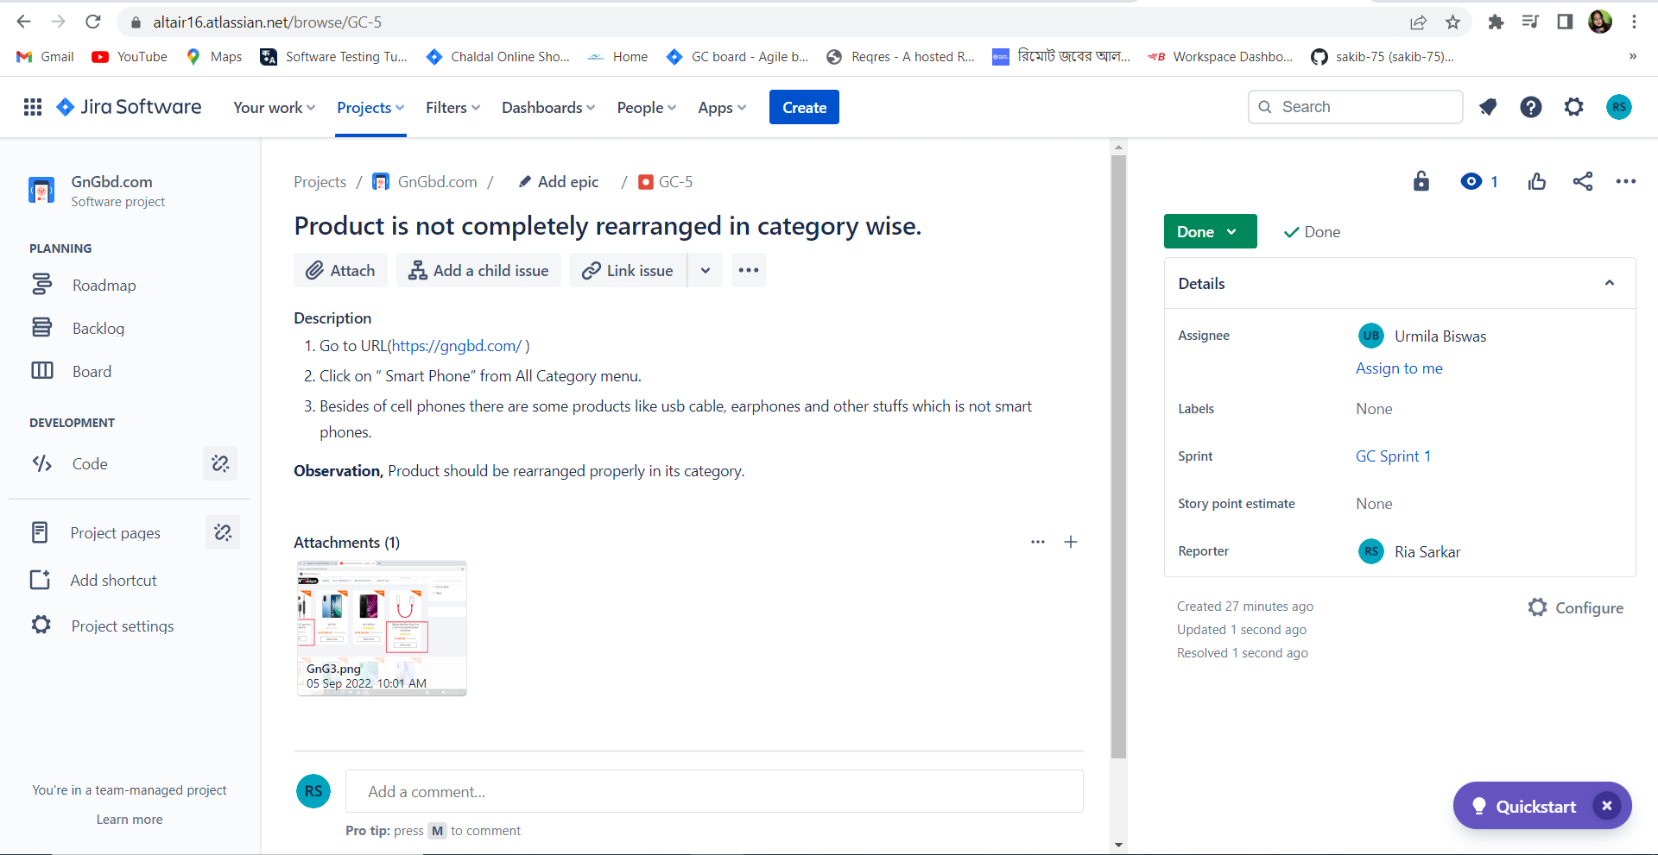

Description: Developer completed the work and the work is done.